Introduction:
This experiment is designed to examine the effect of osmotic balance on the cell membrane.

The vacuole of beetroot plants contains a red pigment, betacyanin, as well as water. Betacyanin will only be found in the vacuole of healthy cells. However, if this membrane becomes damaged, the red pigment will leak out into the surrounding area and indicate the death of the cell. The intensity of the red colour is proportional to the amount of cellular damage.

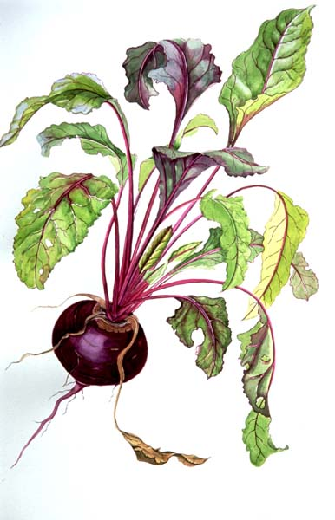
While some salt is essential for plant growth, too much can kill plants as water moves out of the cell through the process of osmosis. A significant reduction in a plant cell’s water content causes osmotic stress which affects membrane integrity.

Beetroot pigment concentration can be measured using a Colorimeter. This device shines a beam of light through a sample of liquid and measures how much light is absorbed by the pigment, compared to a colourless solution. The absorbance of light will be used to monitor the extent of cellular membrane damage.

Aim:
- Use a Colorimeter to measure colour changes due to disrupted cell membranes.
- Determine the effect of osmotic balance on biological membranes.

Equipment:

- Gloves
- Beetroot
- Scalpel/knife
- Plastic ruler
- Chopping board
- 12 test tubes
- Test tube holder
- Plastic Petri dish
- Toothpick
- 10ml measuring cylinder
- Tweezers
- Stop watch/timer
- Prepared solutions of salt (3%, 6%, 9%, 12%, 15%)
- Distilled water
- Marking pen
- Data logger
- Calorimeter
- 6 cuvettes
- Plastic pipette
- Lint free tissues

Procedure:
CARE SHOULD BE TAKEN DURING THIS EXPERIMENT TO NOT CONTAMINATE EACH SAMPLE. ALWAYS START WITH THE LOWEST CONCENTRATION AND WORK TO THE HIGHEST
  - Set up 6 test tubes and number them 1 to 6. Carefully measure 10mL of each of the salt solutions (starting with the lowest % of salt and working up to the highest) and add to the appropriate test tube. Tube number 1 should only have dH₂O in it.

Tube Number | Volume (mLs) | [Salt] %
1 | 10 | 0
2 | 10 | 3
3 | 10 | 6
4 | 10 | 9
5 | 10 | 12
6 | 10 | 15
  - Accurately cut 18 (5mm x 5mm x 5mm) cubes of beetroot.
  - Rinse the cubes twice to remove pigment from damaged cells. Drain and carefully pat dry with a paper towel.
  - Place 3 beetroot cubes into each test tube and allow to sit for exactly 10 minutes. Using the plastic pipette, mix the tubes gently every minute.
  - Label 6 more test tubes the same as in step 1.
  - After the 10 minutes carefully decant the solutions into the new test tubes taking care to not let any beetroot fall in.
  - Set up 6 plastic cuvettes the same as the test tubes. Use a plastic pipette to fill the cuvette ¾ full. Carefully wipe the smooth side of the cuvette with tissue.
  - Your teacher will set up the data logger as follows: Colorimeter and select DATAMATE program. Press clear to reset the program. Set the wavelength on the Colorimeter to 470nm (Blue). Prepare a blank by ¾ filling a cuvette with distilled water, cap the cuvette and place in the colorimeter.
  - Follow teacher instructions to calibrate your Colorimeter.
  - Once calibrated, you may measure the absorbance of each sample by ¾ filling a cuvette with the liquid from tubes 1 to 6.
  - Enter the absorbance data in the table below.

Results:
Sample | % Salt | Absorbance
1 | 0
2 | 3
3 | 6
4 | 9
5 | 12
6 | 15

Draw a graph of your data plotting %salt on x-axis versus absorbance on the y-axis on the next page.

Discussion:
- Which concentration of salt produced the most intensely red solution? Using your knowledge of osmosis explain why this happened.
- Which concentration of salt produced the least intensely red solution? Using your knowledge of osmosis explain why this happened.
- Which salt concentration(s) had the least effect on the beet membrane? How did you arrive at this conclusion?
- Did more damage occur at high or low salt concentrations? Explain why this might be so.
- An effective way to kill a plant is to pour salt onto the ground where it grows. How might the salt prevent the plant’s growth? Is this consistent with your data?
- How reliable are your results? Explain.
- How could you modify this experiment to improve your results?

Conclusion: Explain your results, describing the how salt concentration affects membrane integrity and the process by which this happens.
_______________________________________________________________________________________________________________________________________________________________________________________________________________________________________________________________________________________________________________________________________________________________________________________________________________________________________________________________________________________________________________________________

